
NATIONAL UNIVERSITIES OF MODERN
LANGUAGES
FACULTY OF ENGINEERING AND COMPUTING
DEPARTMENT OF SOFTWARE ENGINEERING

Course Name: WEB-II
Assignment No./ LAB – Task /Project LAB 6: Working with States in React JS
Date: 10 Oct, 2025
Submitted by
Class: BSSE (VII) Section - Sessions (M/A) Afternoon
Name: Zulqarnain hassan Roll No. Sp-21379
Submitted to
Instructor Name: Mr. Danish
To be filled by Instructor
Instructor Comments:
Marks Obtained: Total Marks:
CLO No. :

LAB 6: Working with States in React JS
Lab Tasks
1. Follow the above steps and
2. Convert all letters typed in the text area to UPPERCASE and LOWERCASE
3. Create a Web page and Enable Dark Mode and Light Mode with a toggle Button.

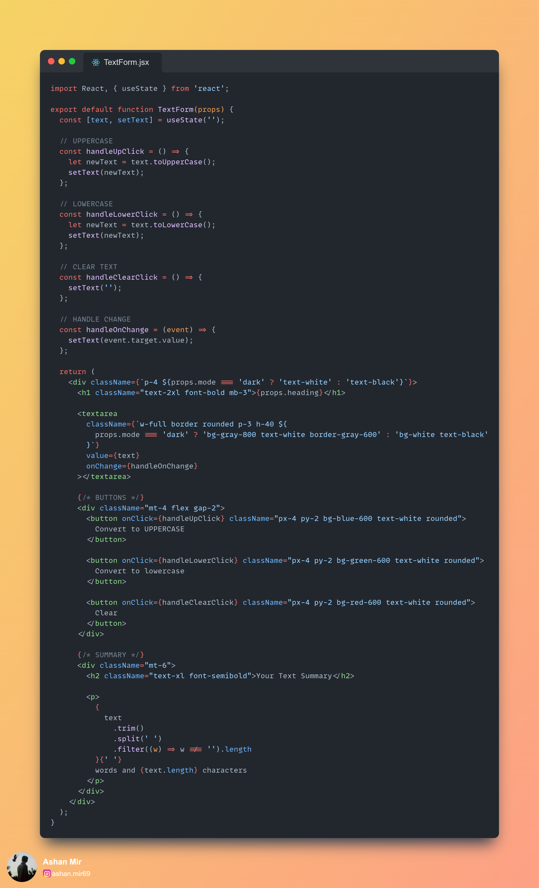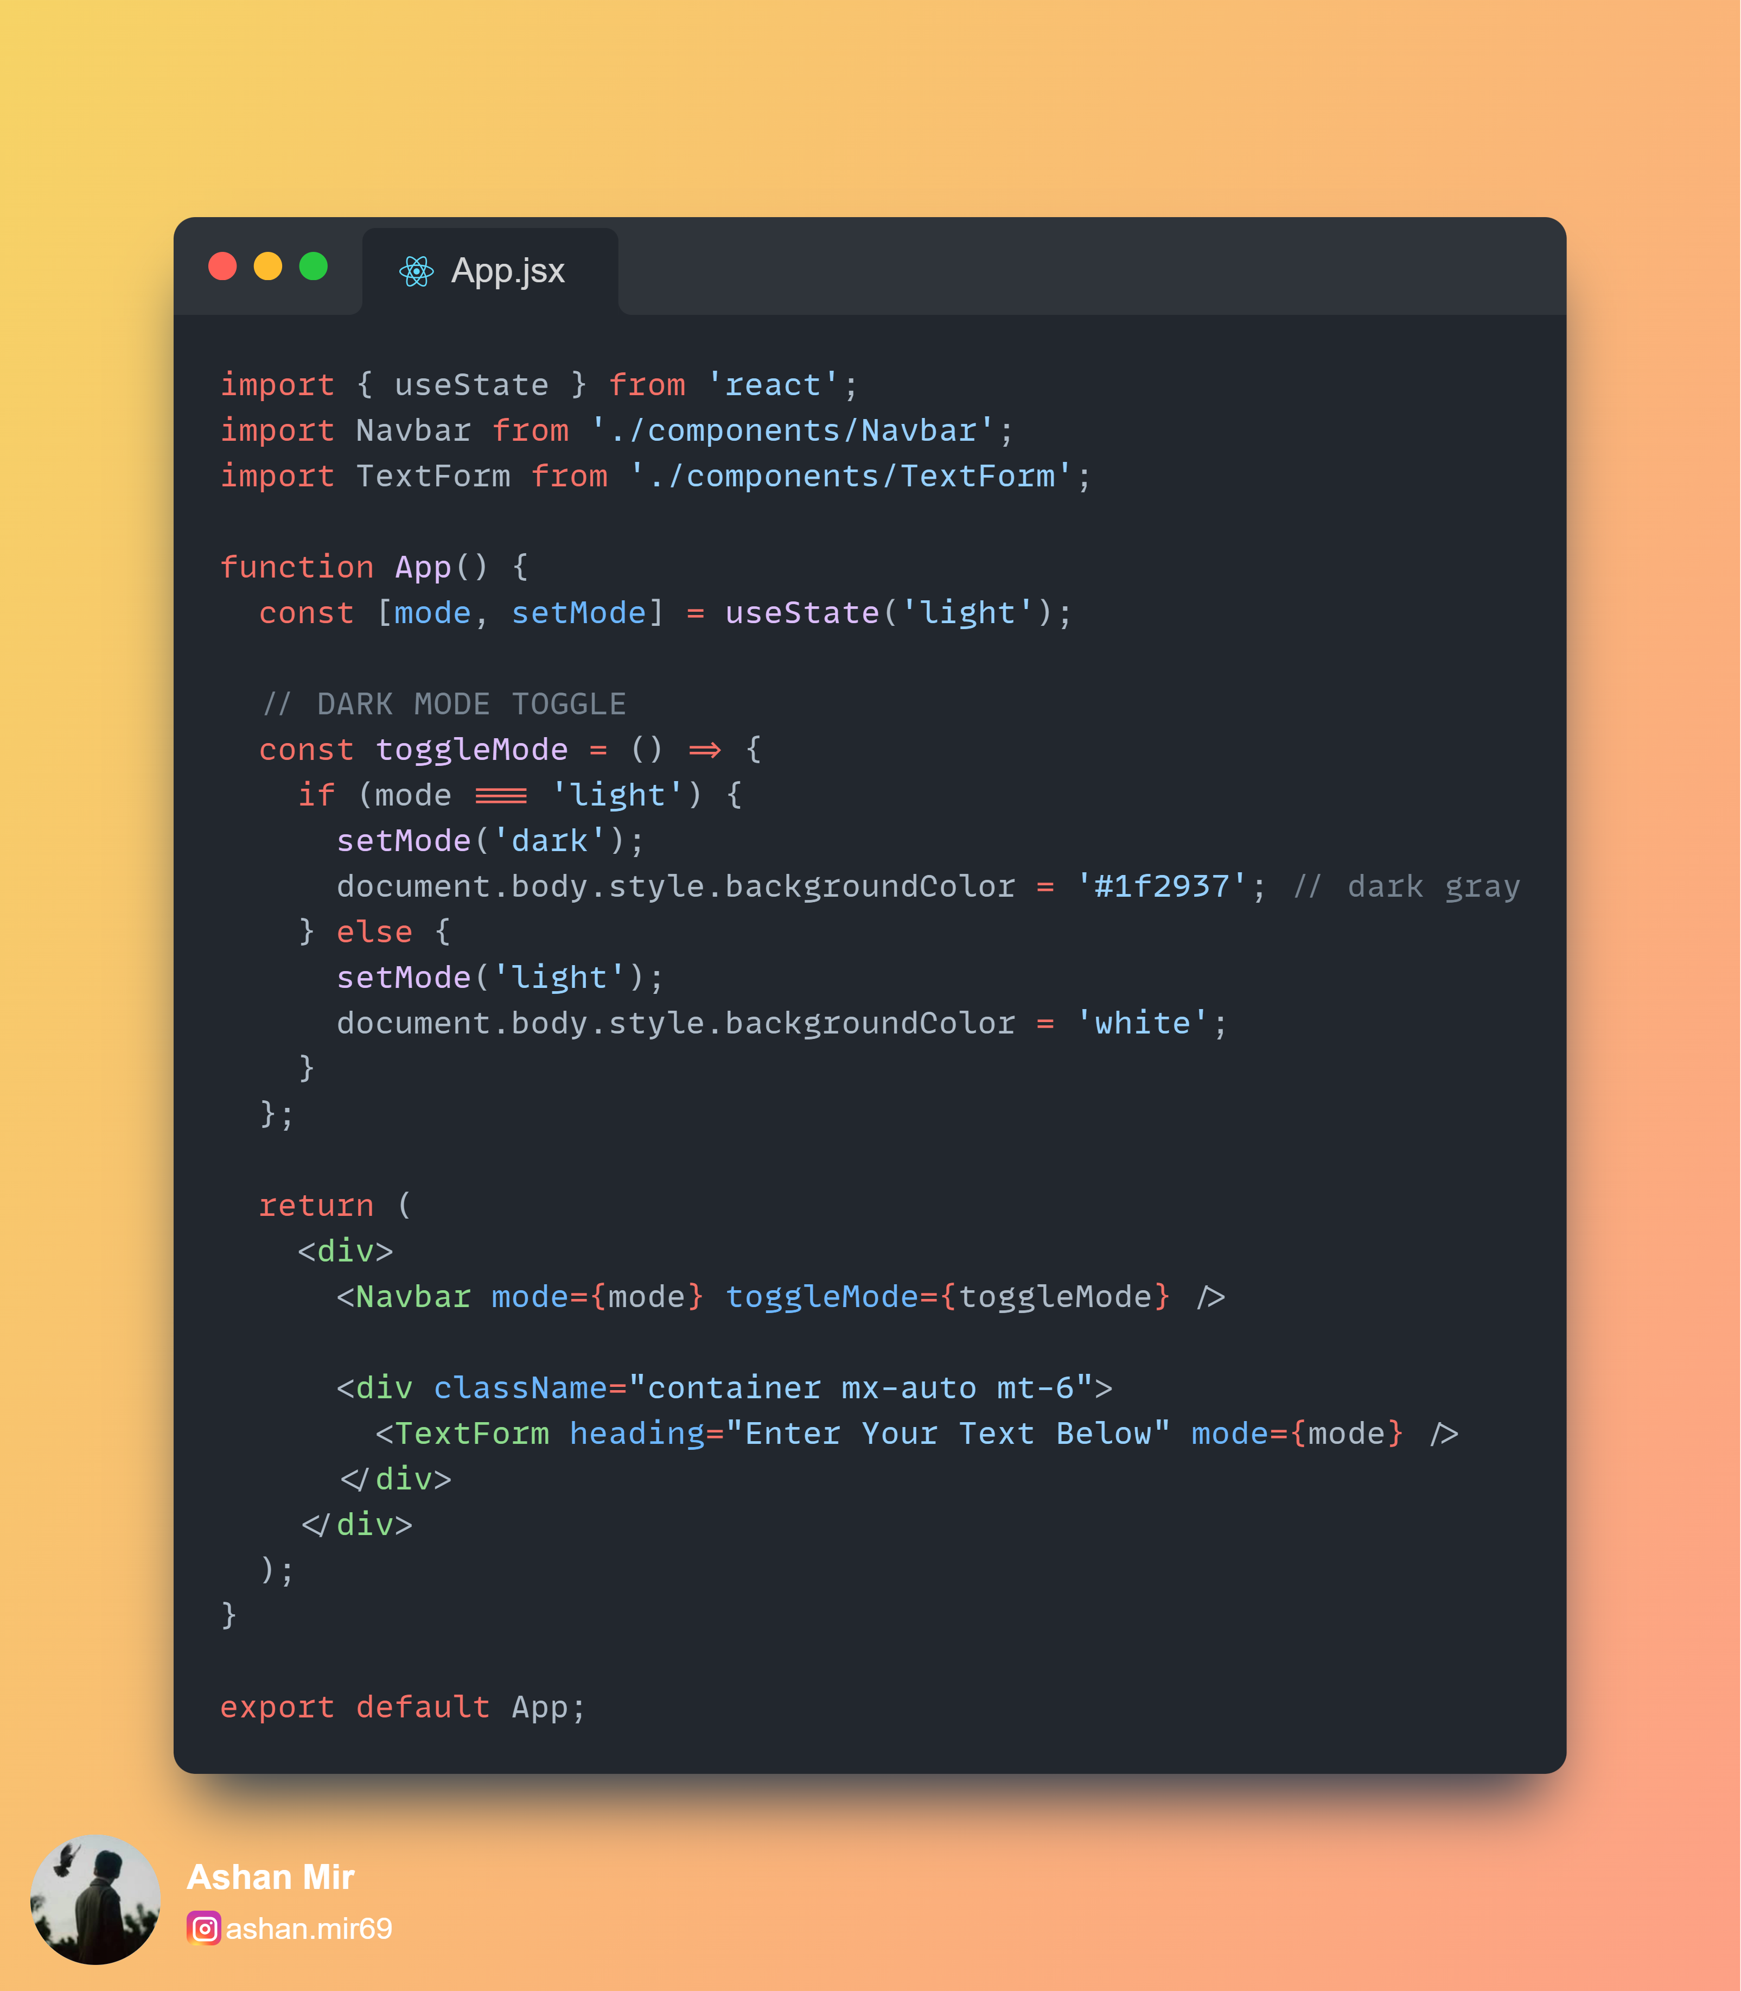

Output:

